Pressure Reducing Valve.

For effectively reducing water pressure down to a desired working pressure. WRAS Approved.
Max Pressure inlet 16 bar
Adjustable range 1.5 – 6 bar.
Max temperature 60 degrees C.
Set from factory at 3 Bar.
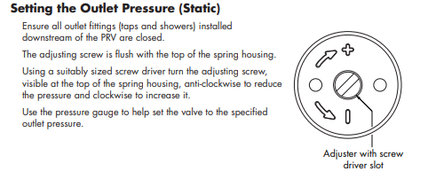
Independent filters are recommended upstream of the valve and the pipe work is fully flushed before installing the valve.
The valve must be protected from frost.
Connections 22 mm compression
Dimensions.
Length 100 mm. Height 95 mm. Width 50 mm
