Pressure Reducing Valve.

For effectively reducing water pressure down to a desired working pressure. WRAS Approved.
Max Pressure inlet 16 bar
Adjustable range 1.5 – 6 bar.
Max temperature 60 degrees C.
Set from factory at 3 Bar.
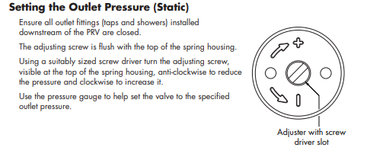
Independent filters are recommended upstream of the valve and the pipe work is fully flushed before installing the valve.
The valve must be protected from frost.
Connections ½” BSP female ( 21mm )
Dimensions.
Length 88 mm. Height 95 mm. Width 50 mm
